Use the command “cd” to change directory to wherever you want to save your files.

Use the command “git clone” to copy whatever is on the git repository to that directory.

Use the command “git fetch” to get the latest version of the git repository.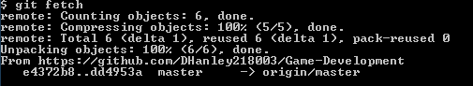

Use the command “git pull” after you first use “git clone” to make sure that changes are merged.

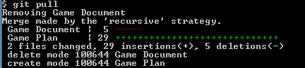

You must use “git commit –m “Comment here” ” before you use git push! Also Please keep a short and relevant comment, and note the comment will affect all files you add.

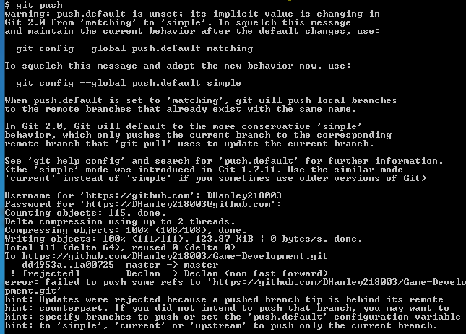

Use the command “git push” and enter your username and password to upload your changes.

